- Reduce part count
  - Replace screws with snap-fit design (e-g: chassis of the car, side of the controller).
  - Replace battery cap with snap-fit (less screw, user-friendly, however, can be troublesome for the waterproof part for the car)
- Product Tiering
  - Low-end line
    - Remove waterproofing (allow non-waterproof/heavier parts)
      - Remove the waterproofing rubber gasket in the car
      - Use smaller/rubber tires
      - Change rubber gears to metal
      - Change shell from PC to ABS
    - Remove LEDs
    - Remove motion-sensing watch
  - High-end line
    - Add charging port with a waterproof compartment
    - Add music/honk
    - Openable doors/windows
    - Add pre-programmed routines (light shows, simple driving sequences)
    - GPS and camera
- Rescale
  - Rescale car/tire
- Controller redesign
  - Controller form
    - Merge the two thumbsticks (controlling up/down and left/right) into one omnidirectional joystick.
    - Merge the two shoulder buttons (controlling clockwise/counter-clockwise) into one.
    - Final form: A single thumbstick for direction + a trigger button for action, resembling one half of a Wii Nunchuk (as shown in the Fig.xx)
  - Controller functions
    - Integrate the motion-sensing capabilities of the watch with the controller, add a button for mode switch
- Abandon the controller and watch
  - Develop smartphone app that functions as controller and motion-sensing.
  - Include the download guide in the packaging
  - (issues: compatibility of phones, e-g, ios/android)
    - 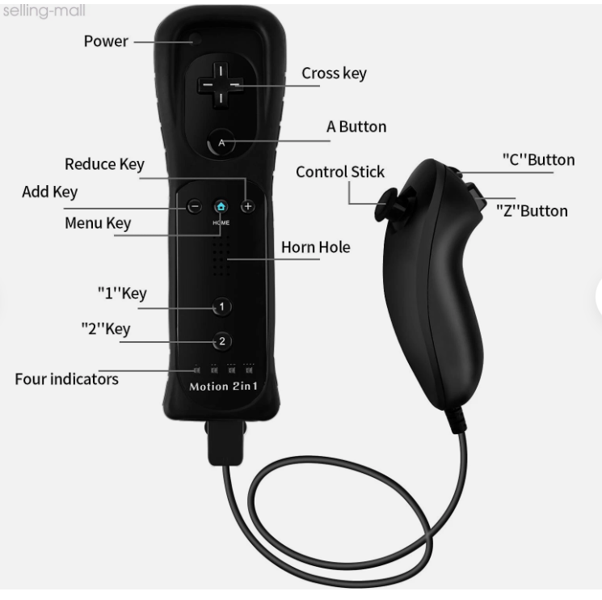

[connections] For the design improvements, we suggest improvements in the following aspects: simplification of …, redesign of controllers,and apply product tiering.
The current design of product is too much with the screws, which could be simplified by applying snap-fit design. Too much screws are bad, because it could lead to an increase in material, as well as complexity in assemblying, as well as in users’ experience. In this product, 12 screws are used for the chassis of the car, and battery caps on both controllers are fixed using screws. We suggest to decrease the use of the screws by:
- Replace screws with snap-fit design (e-g: chassis of the car, side of the controller).
- Replace battery cap with snap-fit (less screw, user-friendly, however, can be troublesome for the waterproof part for the car)

We also realize the design of the controllers are inefficient and redundant, which can be solve by either 1) integrate both parts and simplify or 2) abandon physical controller and develop an app. Currently, the controller have 2 joysticks and 2 shoulder buttons, with 2 joystick controlling 4 directions and shoulder buttons controlling 2 rotation directions, which is redundant and could be achieved by only 1 joystick and 1 shoulder button. Therefore, we suggest:
- Merge the two thumbsticks (controlling up/down and left/right) into one omnidirectional joystick.
- Merge the two shoulder buttons (controlling clockwise/counter-clockwise) into one.
- Final form: A single thumbstick for direction + a trigger button for action, resembling one half of a Wii Nunchuk (as shown in the Fig.xx)
This way, the design is more efficient and cost-effective. From the BOM, we find the cost of the controllers is almost xx percent of the entire product, to make the price more affordable, we can even just abandon them:
- Develop smartphone app that functions as controller and motion-sensing.
- Include the download guide in the packaging
- (issues: compatibility of phones, e-g, ios/android)

Finally, we also suggest implementing product tiering strategy to broaden our clients. This includes creating a more cost-effective base model and a premium model with more features.
  - Remove waterproofing (allow non-waterproof/heavier parts)
    - Remove the waterproofing rubber gasket in the car
    - Use smaller/rubber tires
    - Change rubber gears to metal
    - Change shell from PC to ABS
  - Remove LEDs
  - Remove motion-sensing watch
For higher-end, we suggest adding additional features and making charging more convenient for the users:
  - Add charging port with a waterproof compartment
  - Add music/honk
  - Openable doors/windows
  - Add pre-programmed routines (light shows, simple driving sequences)
  - GPS and camera

